ECE 5362 – Homework 4

1. a) ot5, ib, comp, p1, oadder

b) Can’t read from and write to the same register in 1 cycle

c) oa, p1, oadder

d) Can’t read from and write to the same register in 1 cycle

e) rac = 1, rn = 2, comp, p1

f) Can’t write and read to the combinational circuit in 1 cycle

g) Can’t have two values on the bus during 1 cycle

h) Can’t have two values on the bus during 1 cycle

i) comp, oa, oadder

j) oadder, ot2, it4

k) Can’t remove value from IR

l) write, oa, p1, oadder, wac = 1, wn = 0, it5

2.

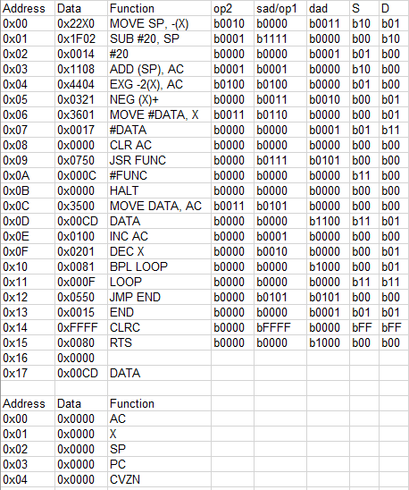

3.

